Certificate of Attendance

This is to confirm that ………………………………………… attended Sue Cowley’s Positive Behaviour Management Webinar on Tuesday 7th July 2020.

Sue Cowley
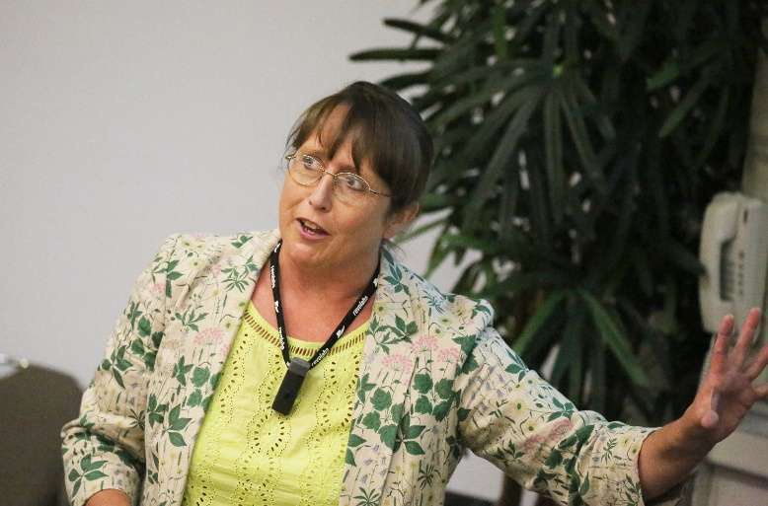
www.suecowley.co.uk
sue@suecowley.co.uk

